Top tips for managing your wellbeing during lockdown!
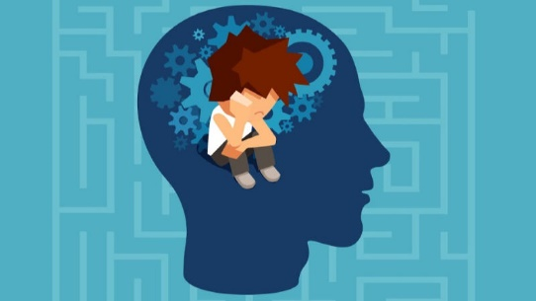
The past year has been difficult for everybody. There isn’t a person alive who has ever been through what we are currently experiencing before! This means that, however and whatever you are feeling right now is normal. Here are a few simple tips to help you look after your wellbeing.

- Recognise that any anxiety you are feeling right now is normal! - If school being closed and constant bad news are making you feel anxious, you are not the only one. Anxiety is a normal and healthy function that alerts us to threats and helps us take measures to protect ourselves. Your anxiety is going to help you make the decisions that you need to be making right now. Those feelings are helping to keep not only you safe, but others too. It is important, however, to make sure the anxiety you are feeling is kept in proportion. If it feels unbearable then speak to someone and ask for help.

- Create distractions – When we are living under difficult conditions, it’s very helpful to divide the problem into two categories: things I can do something about, and then things I can do nothing about. There is a lot that falls under that second category right now, and that’s okay, but one thing that helps us to deal with that is creating distractions for ourselves. This can be doing homework, watching a favourite film or relaxing with a book.

- Find new ways to connect with your friends –If you want to spend time with friends while you’re practicing physical distancing, social media is a great way to connect. But it’s not a good idea to have unlimited access to screens and/or social media. That’s not healthy and it may amplify your anxiety.

- Focus on you – Try to see the extra time you now have on your hands as an opportunity to do more nice things for you. Focusing on yourself and finding ways to use your new-found time is a productive way to look after your mental health.

- Let yourself feel – Missing out on events with friends, hobbies, or sports matches is incredibly disappointing. The best way to deal with this disappointment is to let yourself feel it. When it comes to having a painful feeling, the only way out is through. If you can let yourself be sad, you’ll start to feel better faster! Processing your feelings looks different for everyone. What’s important is that you do what feels right to you.

- Be kind to yourself and others – We normally measure wellbeing by a person’s ability to manage everyday life stresses, but it is important to remember that we are living in circumstances which are not normal. Don’t put pressure on yourself to be or feel a certain way. It is also worth remembering that even good relationships can be tested in lockdown. Try to treat your friends and family with patience and kindness. Remember they are probably feeling just as overwhelmed as you!

